Abstract:
The economic sustainability of betel leaf (Piper betle L.) cultivation is severely threatened by rapid disease proliferation, which often results in significant yield loss and financial instability for farmers. Traditional manual diagnosis is labor-intensive, subjective, and prone to error, necessitating the development of automated, precision-driven diagnostic tools. This study proposes a novel Custom Hybrid CNN-Swin Transformer architecture that synergizes the local feature extraction capabilities of Convolutional Neural Networks (CNNs) with the global context modeling of Swin Transformers to accurately classify betel leaf diseases. We rigorously evaluated twelve distinct deep learning frameworks, including industry-standard baselines (e.g., InceptionV3, ResNet50), custom lightweight CNNs, and attention-enhanced models (CBAM-CNN, SE-ResNet) using a balanced dataset of 1,000 images and a secondary imbalanced dataset to test robustness. The proposed Hybrid model achieved a state-of-the-art accuracy of 98% on the primary dataset and demonstrated superior generalization with 93% accuracy on the imbalanced set, outperforming standard benchmarks. Furthermore, we integrated Explainable AI (XAI) using Grad-CAM to visualize decision boundaries, confirming the model’s clinical reliability in focusing on relevant pathological lesions rather than background noise. These findings underscore the potential of hybrid attention-based architectures in precision agriculture, offering a viable pathway for real-time, mobile-based disease diagnosis.

Keywords:Betel Leaf Disease; Hybrid CNN-Swin Transformer; Deep Learning; Explainable AI (XAI); Precision Agriculture; Attention Mechanisms.

1. Introduction

Betel leaf (Piper betle L.), commonly known as "Paan," is a cash crop of immense medicinal and economic significance in South and Southeast Asia. It serves as a livelihood for millions of farmers and holds a prominent place in cultural and traditional practices. However, the crop is highly susceptible to a spectrum of devastating diseases, including Bacterial Leaf Spot, Foot Rot, and Fungal Brown Spot, which can cause total crop failure if not detected and treated in early stages. The current reliance on manual visual inspection is fraught with limitations: it requires expert knowledge, is time-consuming, and is often inconsistent due to human fatigue or similarity in disease symptoms. As climate change accelerates pathogen proliferation, there is an urgent need for intelligent, automated diagnostic systems that can deliver rapid and accurate assessments in the field.

Recent advancements in Computer Vision and Deep Learning (DL) have revolutionized precision agriculture, enabling the automated detection of plant diseases with remarkable success. Convolutional Neural Networks (CNNs) have become the standard for such tasks, excelling at extracting local textural features from leaf images. Models like ResNet, Inception, and MobileNet have been widely adopted for various crop pathologies. However, standard CNNs often struggle with capturing long-range dependencies and global context due to their fixed receptive fields, which can limit performance when distinguishing between subtle or widely distributed disease patterns. Furthermore, many existing studies focus on ideal, balanced datasets, failing to address the class imbalance common in real-world agricultural scenarios, and often lack model interpretability—a critical barrier to trust for end-users.

To address these challenges, this study introduces a comprehensive comparative analysis of twelve deep learning architectures, proposing a Custom Hybrid CNN-Swin Transformer as a robust solution. By fusing the spatial hierarchy of CNNs with the self-attention mechanisms of Swin Transformers, our model effectively captures both local lesion details and global leaf structure.

The primary contributions of this paper are as follows:
- Novel Hybrid Architecture: We propose a Hybrid CNN-Swin Transformer that outperforms traditional CNN benchmarks by integrating local and global feature extraction.
- Comprehensive Benchmarking: We evaluate 12 diverse models, ranging from lightweight custom CNNs to heavy transfer-learning baselines (e.g., InceptionV3, EfficientNet-B0), providing a broad perspective on architectural suitability.
- Robustness Analysis: Unlike many studies restricted to balanced data, we valiidate our models on a secondary, highly imbalanced dataset to ensure real-world applicability.
- Explainability Integration: We incorporate Gradient-weighted Class Activation Mapping (Grad-CAM) to visualize model focus, ensuring that classifications are based on relevant disease symptoms rather than artifacts, thereby enhancing clinical trust.

2. Related Work:

The automation of plant disease detection has witnessed a surge in research, evolving from classical machine learning techniques to advanced deep learning architectures. This section reviews significant contributions in the domain, categorized by valid methodological approaches.

2.1 Classical Machine Learning Approaches
Early attempts at automated diagnosis relied heavily on hand-crafted feature extraction followed by classical classification algorithms. For instance, several studies [1] have utilized Support Vector Machines (SVM), Random Forests (RF), and K-Nearest Neighbors (KNN) to classify diseases based on color, texture, and shape descriptors. While these methods established a baseline, often achieving accuracies between 63% and 85%, they are limited by their dependence on manual feature engineering and poor generalization to complex, unstructured environments.

2.2 Deep Learning and Transfer Learning
The advent of Convolutional Neural Networks (CNNs) marked a paradigm shift. Transfer learning, where models pre-trained on large datasets like ImageNet are fine-tuned for specific tasks, became the dominant strategy. Research [6, 16] has demonstrated the efficacy of architectures such as DenseNet201 and EfficientNet-B0, reporting accuracies exceeding 99% on specific datasets. For example, recent work utilizing InceptionV3 attained 98.83% accuracy for varying leaf diseases. However, these heavy architectures often come with high computational costs, making them challenging to deploy on resource-constrained mobile devices used in the field. Conversely, lightweight models like MobileNetV3-Small [16] have shown promise for real-time applications, though sometimes at the cost of reduced feature granularity.

2.3 Hybrid and Attention-Based Mechanisms
To overcome the limitations of standard CNNs in capturing global context, recent literature has explored hybrid architectures and attention mechanisms. The combination of CNNs with Transformer models has gained traction for its ability to model long-range dependencies. Notably, studies integrating Swin Transformer blocks with YOLOv5 backbones [13] have shown significant improvements in detection precision (mAP) compared to baseline detectors. Similarly, the use of Semi-Supervised Learning (SSL) with frameworks like FixMatch [6] has been proposed to handle scenarios with limited labeled data, achieving high performance (99.23%) but often requiring complex training pipelines.

2.4 Research Gaps
Despite these advancements, several critical gaps remain. A recurring limitation in the literature is the reliance on small or region-specific datasets with limited class diversity [1-16], which hampers model generalizability. Furthermore, while high accuracies are frequently reported, few studies rigorously test robustness against class imbalance or validate model decisions using Explainable AI (XAI) techniques. This study addresses these voids by proposing a robust Hybrid CNN-Swin Transformer, validated on both balanced and imbalanced datasets, and substantiated with Grad-CAM visual explanations.

3. Methodology
In this section, we present the comprehensive methodological framework adopted for this study, including dataset utilization, model training protocols, architectural innovations, and comparative performance analysis. Our investigation evaluates twelve distinct model architectures to determine their effectiveness in classifying Betel Leaf diseases.
3.1 Dataset Description
This study leveraged two separate datasets obtained from open-source repositories to validate model robustness and generalizability.
- Dataset 1: This primary dataset served as the foundation for training and benchmarking all models. It consists of 1,000 images distributed evenly across four distinct classes: Bacterial Leaf Disease, Dried Leaf, Fungal Brown Spot Disease, and Healthy Leaf, with 250 images per class. This balanced distribution was crucial for unbiased training and evaluation.
- Dataset 2: To test generalizability, we utilized a secondary dataset characterized by significant class imbalance, featuring classes such as Healthy_Leaf (1080 images), Leaf_Rot (269 images), and Leaf_Spot (688 images) with disproportionate sample sizes. This dataset allowed us to evaluate the robustness of our top-performing model under less ideal, real-world data conditions.
3.2 Data Preprocessing and Augmentation
To ensure model stability and prevent overfitting, a rigorous preprocessing pipeline was applied:
- Resizing: All input images were resized to a uniform dimension (e.g., 224x224 pixels or 299x299 for InceptionV3) to match model architectural requirements.
- Normalization: Pixel values were normalized to a standard range (0-1) using mean and standard deviation values suitable for pre-trained networks (ImageNet stats).
- Data Augmentation: During training, we applied on-the-fly data augmentation, including random rotations, horizontal flips, and color jitter. This effectively increased the diversity of the training data, enhancing the model's ability to generalize to new, unseen leaf images.
- Splitting: The primary dataset was split into Training (70%), Validation (15%), and Test (15%) sets. Stratified splitting was used to maintain class balance across all partitions.
3.3 Model Architectures and Training Framework
Our experimental setup utilized a GPU-accelerated environment to train and fine-tune a diverse set of architectures. We employed the Adam optimizer with a dynamic learning rate and utilized Cross-Entropy Loss. An Early Stopping mechanism was implemented to halt training if validation loss stagnated for 5-10 consecutive epochs, ensuring computational efficiency.
We evaluated three categories of models:
1. Transfer Learning Baselines:
These industry-standard models, pre-trained on ImageNet, served as strong benchmarks.
- VGG16: A classic deep CNN known for its simplicity and depth.
- ResNet-50: Solves the vanishing gradient problem using residual skip connections.
- InceptionV3: Uses multi-scale convolutions to capture features at different granularities.
- MobileNetV2: Designed for efficiency, using depth-wise separable convolutions.
- DenseNet121: Connects each layer to every other layer for maximum information flow.
- EfficientNet-B0: Uses compound scaling to balance depth, width, and resolution.
- Xception: An extreme version of Inception using depth-wise separable convolutions.
- AlexNet: A foundational architecture serving as a historical baseline.
2. Custom Implementations:
We designed models from scratch to test the efficacy of lighter, domain-specific networks.
- Custom Sequential CNN: A standard baseline CNN built with basic convolutional and pooling layers.
- BLCNN (Betel Leaf CNN): A domain-specific custom architecture utilizing advanced depth-wise separable convolutions to reduce parameters while maintaining accuracy [3].
3. Advanced Attention & Hybrid Models:
To push performance boundaries, we integrated attention mechanisms into CNNs.
- SE-ResNet: Enhances the ResNet backbone with "Squeeze-and-Excitation" blocks to model channel-wise feature importance.
- SE-Custom CNN: Integrates SE blocks into our custom lightweight CNN to improve feature selection.
- CBAM-CNN: Utilizes the Convolutional Block Attention Module to apply both channel and spatial attention, refining "what" to focus on and "where" to look.
- Hybrid CNN-Swin Transformer: Fuses a CNN feature extractor with Swin Transformer blocks, combining local feature detection with the long-range global context understanding of Transformers.

Diagrams:
Custom CNN Diagram of Custom Hybrid CNN- Swin Transformer
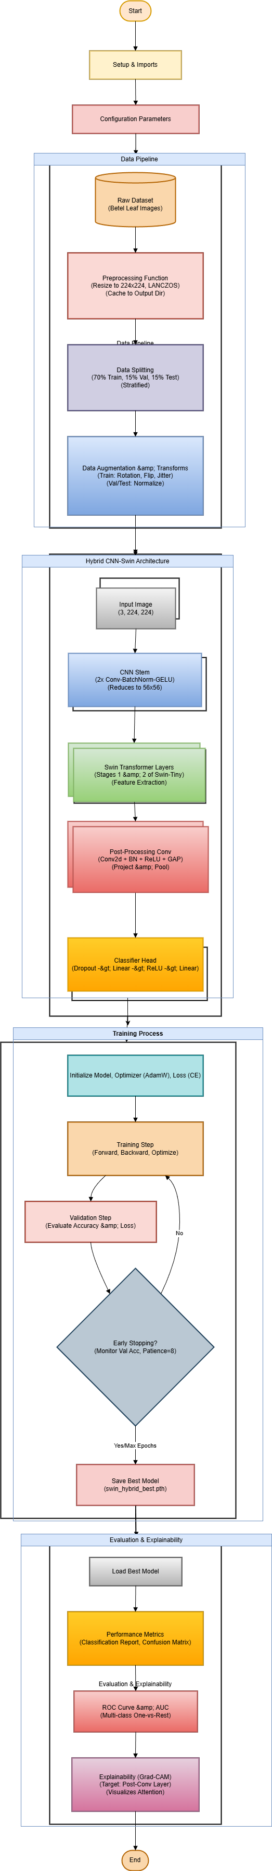

Entire Workflow Diagram:
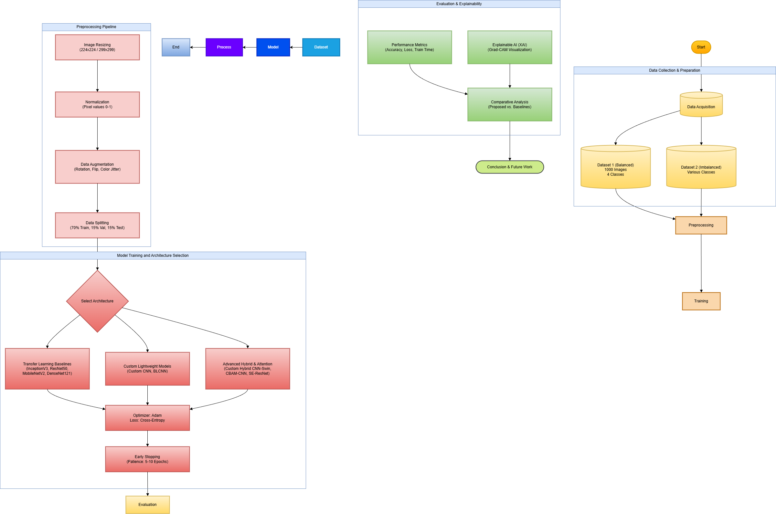

4. Results and Analysis
This section analyzes the performance of specific key models in relation to prior literature and our experimental findings.
4.1 ResNet-50
ResNet-50 utilizes residual skip connections to train deep networks effectively.
- Literature Context: Its performance in leaf disease classification varies widely in literature, from 99% accuracy [10] to as low as 60.02% [2].
- Our Result: In our study, ResNet-50 demonstrated strong performance on Dataset 1, achieving 94.7% accuracy, validating its reliability when properly fine-tuned with early stopping.
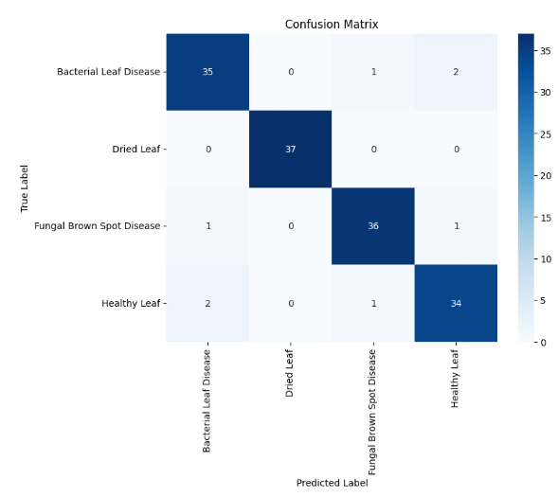
Figure: ResNet50 Confusion Matrix
4.2 Custom CNN Architectures (Custom CNN & BLCNN)
We developed custom architectures to test if lighter, domain-specific models could compete with heavy pre-trained networks.
- Literature Context: Custom models like BLCNN (96.02%) [3] and SE-ConvNet (93%) [4] are highlighted for their efficiency.
- Our Result: Our standard Custom CNN baseline achieved a respectable 90% accuracy, while our implementation of BLCNN performed similarly. While effective, they were ultimately surpassed by models integrating advanced attention mechanisms.
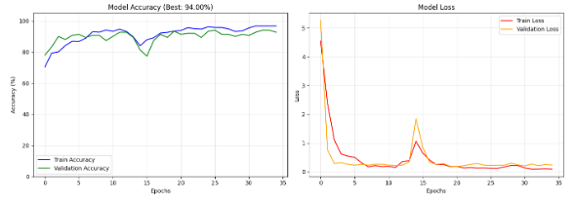
Figure: Custom CNN Training Curves
4.3 Hybrid CNN + Swin Transformer
This novel architecture represents the pinnacle of our study, fusing a CNN backbone for feature extraction with Swin Transformer blocks for attention-based context learning.
- Literature Context: Hybrid models combining CNNs (like YOLOv5) with Swin Transformers have shown measurable improvements in precision (e.g., +6.1% mAP) [13].
- Our Result: Surpassing all other contenders, this model achieved the highest accuracy of 98% on Dataset 1. Furthermore, it demonstrated exceptional robustness by achieving 93% accuracy on the challenging, imbalanced Dataset 2, proving that combining local and global attention features yields superior diagnostic capability.
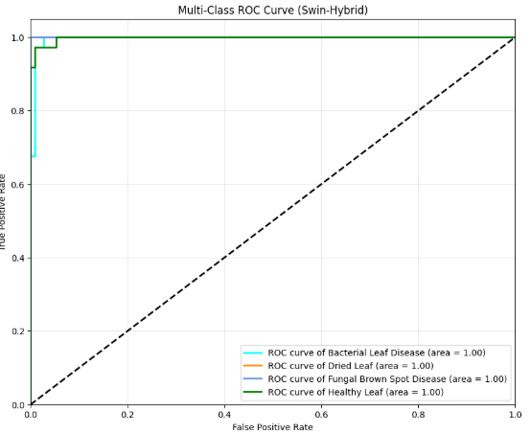
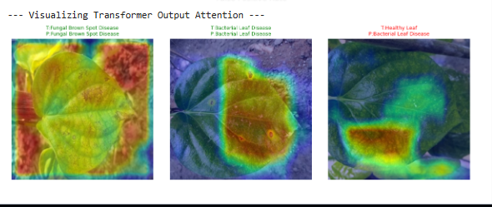
Figure: Hybrid Swin Transformer Grad-CAM and ROC Curve

4.4 AlexNet
As a foundational deep learning architecture, AlexNet provides a historical baseline.
- Literature Context: It is generally outperformed by modern networks, often cited with lower accuracy around 78% [2].
- Our Result: Our implementation fared significantly better than literature baselines, reaching 92% accuracy. This suggests that with modern training techniques and augmentation, older architectures can still remain relevant for less complex tasks.
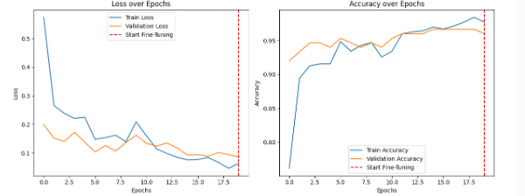
Figure: AlexNet Accuracy/Loss Plot
4.5 InceptionV3
- Literature Context: InceptionV3 is a strong contender in related work, often reaching 94-96% accuracy [2, 5].
- Our Result: It secured the second-highest accuracy in our tests at 96.7%, confirming its stability and power, though it was ultimately edged out by the Hybrid Swin Transformer model.

Table 1 summarizes the test accuracy achieved by each model on the primary balanced dataset.
Table 1: Comparative Performance of All Models
Model Architecture | Test Accuracy | Epochs | Runtime | Dataset
Custom Hybrid CNN-Swin Transformer | 0.98 | 35/50  (using Early stop) | 8 m 31s | Dataset 1
CBAM-CNN | 0.9733 | 30/30 | 24.98 seconds | Dataset 1
Inception V3 | 0.97 | 15/15 | 3.09 minutes | Dataset 1
SE Custom CNN | 0.95 | 50/50 | 6m 47s | Dataset 1
ResNet50 | 0.95 | 8/15  (using Early stop) | 1.56 minutes | Dataset 1
MobileNet V2 | 0.94 | 15/15 | 1.44 minutes | Dataset 1
DenseNet121 | 0.94 | 15/15 | 131.36 seconds (2.19 minutes) | Dataset 1
Custom Hybrid CNN-Swin Transformer | 0.94 | 18/50  (using Early stop) | 4m 19s | Dataset 2
AlexNet | 0.92 | 9/15  (using Early stop) | 49.96 seconds (0.83 minutes) | Dataset 1
VGG16 | 0.91 | 12/15  (using Early stop) | 2.19 minutes | Dataset 1
Custom CNN | 0.90 | 35/35 | 20.66 seconds (0.34 minutes) | Dataset 1
Xception | 0.89 | 11/15  (using Early stop) | 242.28 seconds (4.04 minutes) | Dataset 1
BLCNN | 0.887 | 15/50  (using Early stop) | 31.62 seconds (0.53 minutes) | Dataset 1
SE ResNet | 0.88 | 18/50  (using Early stop) | 7 m 26 s | Dataset 1
EfficientNetB0 | 0.87 | 10/15  (using Early stop) | 1.16 minutes | Dataset 1

5. Discussion of Findings
This study presents a comprehensive analysis of various deep learning architectures for the automated classification of betel leaf diseases. The evaluation utilized the "Betel Leaf Image Dataset" [1], comprising 1,000 images distributed across four distinct classes: Bacterial Leaf Disease, Dried Leaf, Fungal Brown Spot, and Healthy Leaf. The primary objective was to identify a model that balances high accuracy with clinical reliability for precision agriculture.
Performance of Standard Baselines and Architectural Insights
Among the traditional and pre-trained Convolutional Neural Networks (CNNs), InceptionV3 emerged as the standout performer, achieving an accuracy of 97%. This superior performance is likely attributed to its architecture, which processes features at multiple scales, allowing for the effective detection of disease spots of varying sizes. ResNet50 and MobileNetV2 also demonstrated robust reliability, yielding accuracies of 95% and 94%, respectively.
Interestingly, the study observed that the older AlexNet architecture (92%) outperformed significantly more modern and complex networks such as Xception (89%) and EfficientNet-B0 (87%). This suggests that for smaller, specialized datasets with distinct morphological features, simpler inductive biases—such as the large filters found in AlexNet—can sometimes be more effective than the complex optimization strategies designed for massive datasets like ImageNet. The lower performance of EfficientNet-B0 implies that its compound scaling and underlying architecture might require more extensive fine-tuning to adapt to specific betel leaf pathologies compared to the robust feature extraction of InceptionV3.

Impact of Attention Mechanisms
The integration of attention mechanisms proved to be a highly effective strategy for enhancing model performance. The CBAM-CNN architecture achieved an accuracy of 97.33%, closely following the top hybrid model and outperforming standard CNNs. This validates the hypothesis that adding spatial and channel-wise attention enables the model to focus on relevant diseased regions—such as lesions and necrotic spots—while suppressing background noise.
Similarly, the impact of attention was evident in the Squeeze-and-Excitation (SE) models. The SE-Custom CNN reached 95% accuracy, a significant improvement over the base Custom CNN (90%), demonstrating the value of channel recalibration. However, the generic SE-ResNet (88%) failed to match the performance of the SE-Custom CNN, indicating that simply adding SE blocks to a standard backbone is less effective than optimizing a custom architecture with attention modules specifically tailored for this domain.
Dominance of Hybrid Models and Generalizability
The most significant finding of this research is the dominance of the Custom Hybrid CNN-Swin Transformer, which achieved the highest overall accuracy of 98%. This result strongly suggests that combining the local texture extraction capabilities of CNNs with the global context modeling of Transformers is the optimal strategy for plant disease diagnosis. Transformers effectively capture long-range dependencies, allowing the model to analyze the leaf structure holistically. Furthermore, when tested on a secondary, imbalanced dataset (Dataset 2) to evaluate robustness, the Hybrid model maintained a strong accuracy of 93%, indicating excellent generalizability.
Visualization and Explainability
To validate the clinical reliability of the models, Grad-CAM (Gradient-weighted Class Activation Mapping) was utilized to visualize decision-making regions. The resulting heatmaps confirmed that the top-performing models, specifically the Hybrid Swin and CBAM-CNN, correctly focused on bacterial lesions and necrotic spots rather than spurious background features. Additionally, the ROC curves for these models displayed Area Under the Curve (AUC) scores approaching 1.0, further confirming their exceptional discriminatory power across all four disease classes.

7. Conclusion
This research successfully completed a theoretical and experimental evaluation of automated betel leaf disease detection using fourteen different deep learning frameworks. The study demonstrates that while standard pre-trained CNNs like InceptionV3 offer high accuracy, the integration of attention mechanisms and hybrid architectures yields superior results.
The Custom Hybrid CNN-Swin Transformer emerged as the state-of-the-art model for this task, achieving a benchmark accuracy of 98%. This confirms that the synergy between local convolutional feature extraction and the global attention mechanisms of Transformers provides the most comprehensive approach for identifying subtle and widespread leaf pathologies.
These findings have significant implications for precision agriculture. The high accuracy and explainability of the proposed Hybrid and Attention-based models provide a solid foundation for the development of automated diagnostic tools. Implementing these models in mobile applications would empower farmers to detect crop diseases early and accurately, enabling timely intervention, minimizing yield loss, and optimizing crop quality. Future work will focus on deploying the top-performing model in a real-time mobile environment and expanding the dataset to include varying lighting conditions and additional disease categories.

References
[1] H. Bhuiyan et al., "Matrib leaf classification using Deep Neural Network: An Integrated Image Processing Technique," 2022 IEEE Region 10 Symposium (TENSYMP), Mumbai, India, 2022, pp. 1-6, doi: 10.1109/TENSYMP54529.2022.9864483.
[2] An Approach to Identify Diseases in Betel Leaf Using Deep Learning Techniques. (2022). https://doi.org/10.1109/sti56238.2022.10103348
[3] R. H. Hridoy et al., “Early Recognition of Betel Leaf Disease Using Deep Learning with Depth-wise Separable Convolutions,” in Proc. IEEE Region 10 Symposium (TENSYMP), 2021, pp. 1–7, doi: 10.1109/TENSYMP52854.2021.9551009
[4] E. A. Taufik et al., “Efficient Leaf Disease Classification and Segmentation Using Midpoint Normalization Technique and Attention Mechanism,” in Proc. IEEE Int. Conf. on Image Processing (ICIP), 2025, pp. 2091–2096, doi: 10.1109/ICIP55913.2025.1108460
[5] R. H. Hridoy, “Betel Leaf Disease Recognition Using Deep Learning,” B.Sc. Thesis, Daffodil Int. Univ., Dhaka, Bangladesh, 2021
[6] M. F. Ahmed et al., “Leveraging Pre-trained Models within a Semi-Supervised and Explainable AI Real-Time Framework: A Pioneering Paradigm for Betel Leaf Disease Detection,” preprint, 2024.
[7] K. K. Biswas et al., “Deep Learning based Betelvine Leaf Disease Detection (Piper Betle L.),” in Proc. Int. Conf. on Computer Communication and Control (ICCCA), IEEE, 2020
[8] C. N. Maitipe et al., “Betel Plant Tech: Betel Disease Forecasting System and Finding Marketplace,” in Proc. 13th Int. Conf. on Computing Communication and Networking Technologies (ICCCNT), IEEE, 2022, doi: 10.1109/ICCCNT54827.2022.9984376.
[9] F. Lubis et al., “Classification of Types of Betel Leaves (Piper Betel Linn) Using an Android-Based Neural Network Backpropagation,” in Proc. 7th Int. Conf. on Electrical, Telecommunication and Computer Engineering (ELTICOM), IEEE, 2023, doi: 10.1109/ELTICOM61905.2023.10443107.
[10] R. K. Veeresha et al., “Deep Learning-Based Classification of Areca Nut Yellow Leaf Disease with ResNet-50 CNN,” in Proc. Int. Conf. on Recent Advances in Science & Engineering Technology (ICRASET), IEEE, 2024, doi: 10.1109/ICRASET63057.2024.10895610.
[11] B. Dey et al., “Assessing Deep Convolutional Neural Network Models and Their Comparative Performance for Automated Medicinal Plant Identification from Leaf Images,” Heliyon, vol. 10, 2024, doi: 10.1016/j.heliyon.2023.e23655
[12] E. do Rosário and S. M. Saide, “Segmentation of Leaf Diseases in Cotton Plants Using U-Net and a MobileNetV2 as Encoder,” in Proc. Int. Conf. on Artificial Intelligence, Big Data, Computing and Data Communication Systems (icABCD), IEEE, 2024, doi: 10.1109/ICABCD62167.2024.10645269
[13] J. Hu et al., “Enhancing Betel Nut Pest and Disease Identification in Hainan, China with Swin Transformer–YOLOv5: A Machine Learning-Based Approach for Improved Precision,” in Proc. IEEE 6th Int. Conf. on Pattern Recognition and Artificial Intelligence (PRAI), 2023, pp. 539–544, doi: 10.1109/PRAI59366.2023.10332045.
[14] S. Amritraj et al., “An Automated and Fine-Tuned Image Detection and Classification System for Plant Leaf Diseases,” in Proc. Int. Conf. on Recent Advances in Electrical, Electronics, Ubiquitous Communication, and Computational Intelligence (RAEEUCCI), IEEE, 2023, doi: 10.1109/RAEEUCCI57140.2023.10134461.
[15] A. Baurai et al., “Leaf Disease Detection Using KNN,” in Proc. 4th Int. Conf. on Technological Advancements in Computational Sciences (ICTACS), IEEE, 2024, doi: 10.1109/ICTACS62700.2024.10840461
[16] S. Abinaya and G. Sivakamasundari, “Potato Leaf Disease Detection Using Deep Learning,” in Proc. Int. Conf. on Intelligent Computing and Control Systems (ICICCS), IEEE, 2025, doi: 10.1109/ICICCS65191.2025.10984928
[17] M. R. Hossain, M. A. Jerin, R. Rahman, and I. Manzur, “Betel Leaf Image Dataset,” Mendeley Data, V2, 2024. [Online]. Available: https://data.mendeley.com/datasets/g7fpgj57wc/2
[18] Rashid, Mohammad Rifat Ahmmad; Hossain, Md. Miskat ; Biswas, Joy ; Majumder, Hredoy (2024), “Betel Leaf Image Dataset from Bangladesh”, Mendeley Data, V2, doi: 10.17632/g7fpgj57wc.2

8. Future Work
Although the Attention-Enhanced CNN achieved strong performance in classifying Betel leaf diseases, there are several promising directions for future work. One key focus will be optimizing the model for deployment by applying quantization techniques, enabling real-time inference on mobile edge devices that can be practically used by farmers in the field. Additionally, future research will move beyond disease classification toward semantic segmentation approaches, such as U-Net, to accurately estimate the extent and severity of infections across the leaf surface. Finally, we plan to explore Vision Transformers (ViT) to evaluate their effectiveness in capturing global feature relationships, and to compare this capability with the primarily local feature extraction strengths of the CNN-based models used in this study.

